**DAY 01**

**19.06.2023**

I have concentrated on choosing an image processing project that makes use of convolutional neural networks (CNN) on the first day of my online internship.

**Image processing**

The modification and analysis of digital pictures fall under the umbrella of this important discipline. It may be used for a wide variety of things, including object identification and autonomous cars as well as medical imaging.

**Convolutional Neural Networks for Image Processing**

CNNs have demonstrated considerable potential in image processing jobs. They are particularly suited for applications like image classification, object identification, and image segmentation because they can automatically learn hierarchical representations from pictures.

*CNN Architectures*

* LeNet
* AlexNet
* VGGNet
* GoogLeNet
* MobileNet
* ResNet
* DenseNet

*Reference*

<https://towardsdatascience.com/understanding-cnn-convolutional-neural-network-69fd626ee7d4>

<https://pub.towardsai.net/convolutional-neural-networks-cnns-tutorial-with-python-417c29f0403f>

**Project: Traffic Sign Detection**

Traffic signs are crucial because they encourage drivers to obey the law and lower the number of accidents on the road. However, it can be quite challenging for a motorist to pay attention to both the signs and other traffic-related events at the same time. In addition, the rapidly developing fields of automated driving and autonomous automobiles depend heavily on the accurate recognition of traffic signs.

*Reference*

<https://www.kaggle.com/datasets/meowmeowmeowmeowmeow/gtsrb-german-traffic-sign>

<https://www.kaggle.com/code/lalithmovva/99-accuracy-on-german-traffic-sign-recognition>

<https://www.kaggle.com/code/shanmukh05/traffic-sign-recognition>

<https://www.kaggle.com/code/sanikamal/traffic-sign-recognition-with-tensorflow>

<https://www.kaggle.com/datasets/wjybuqi/traffic-sign-classification-and-recognition>

**Traffic Sign Detection using CNNs 99% Accuracy**

[German Traffic Sign Recognition Benchmark](https://www.kaggle.com/meowmeowmeowmeowmeow/gtsrb-german-traffic-sign) Dataset which has lifelike images of traffic signs have been classified into 43 classes. The train and test sets combined consist of more than 50000 images. Convolutional Neural Network (CNN) is used for this purpose and achieve a **test set accuracy of more than 99%**.

<https://www.kaggle.com/code/raghav2002sharma/traffic-sign-detection-using-cnns-99-accuracy>

**Accuracy Obtained: 99 %**

**Fitting the model**

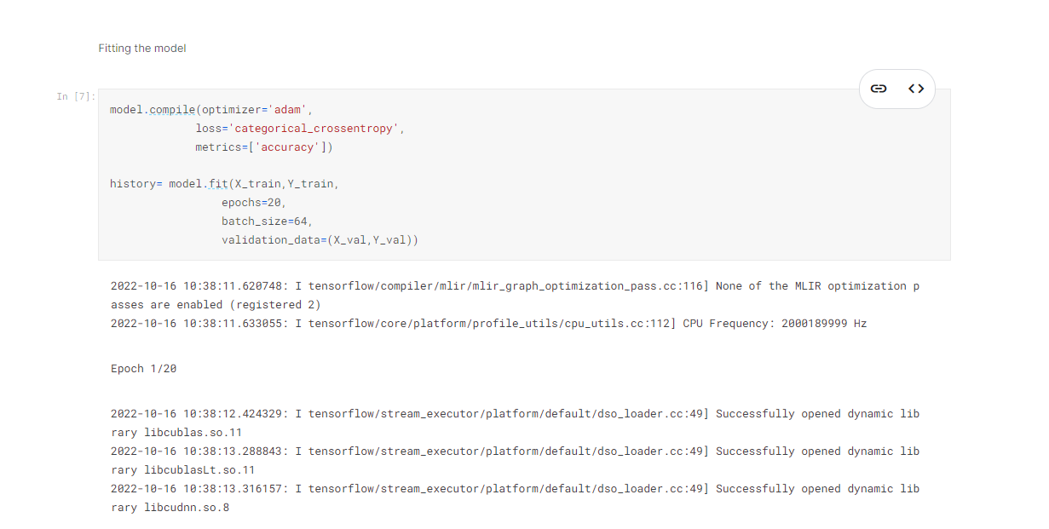

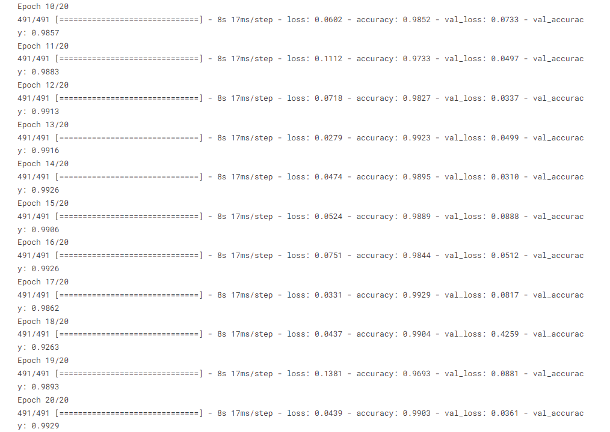

**Train Evaluation**

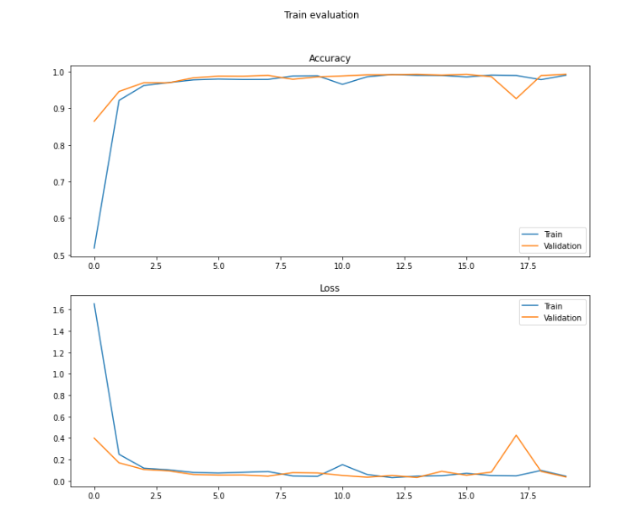

**Accuracy**

